Project Section B
Group 3: Isaiah Jernigan, Andrew Shappell, James Wang, Li Zhe Yow, Milan Deepak, Mohammad Alqattan
1. Apply four supervised machine learning algorithms to analyze the labeled dataset and classify the traffic using each machine learning approach. One of the supervised ML algorithms that should be included in your analysis is Random Forest You will submit the Python code for each experiment as part of your submission.
Logistic Regression Model:
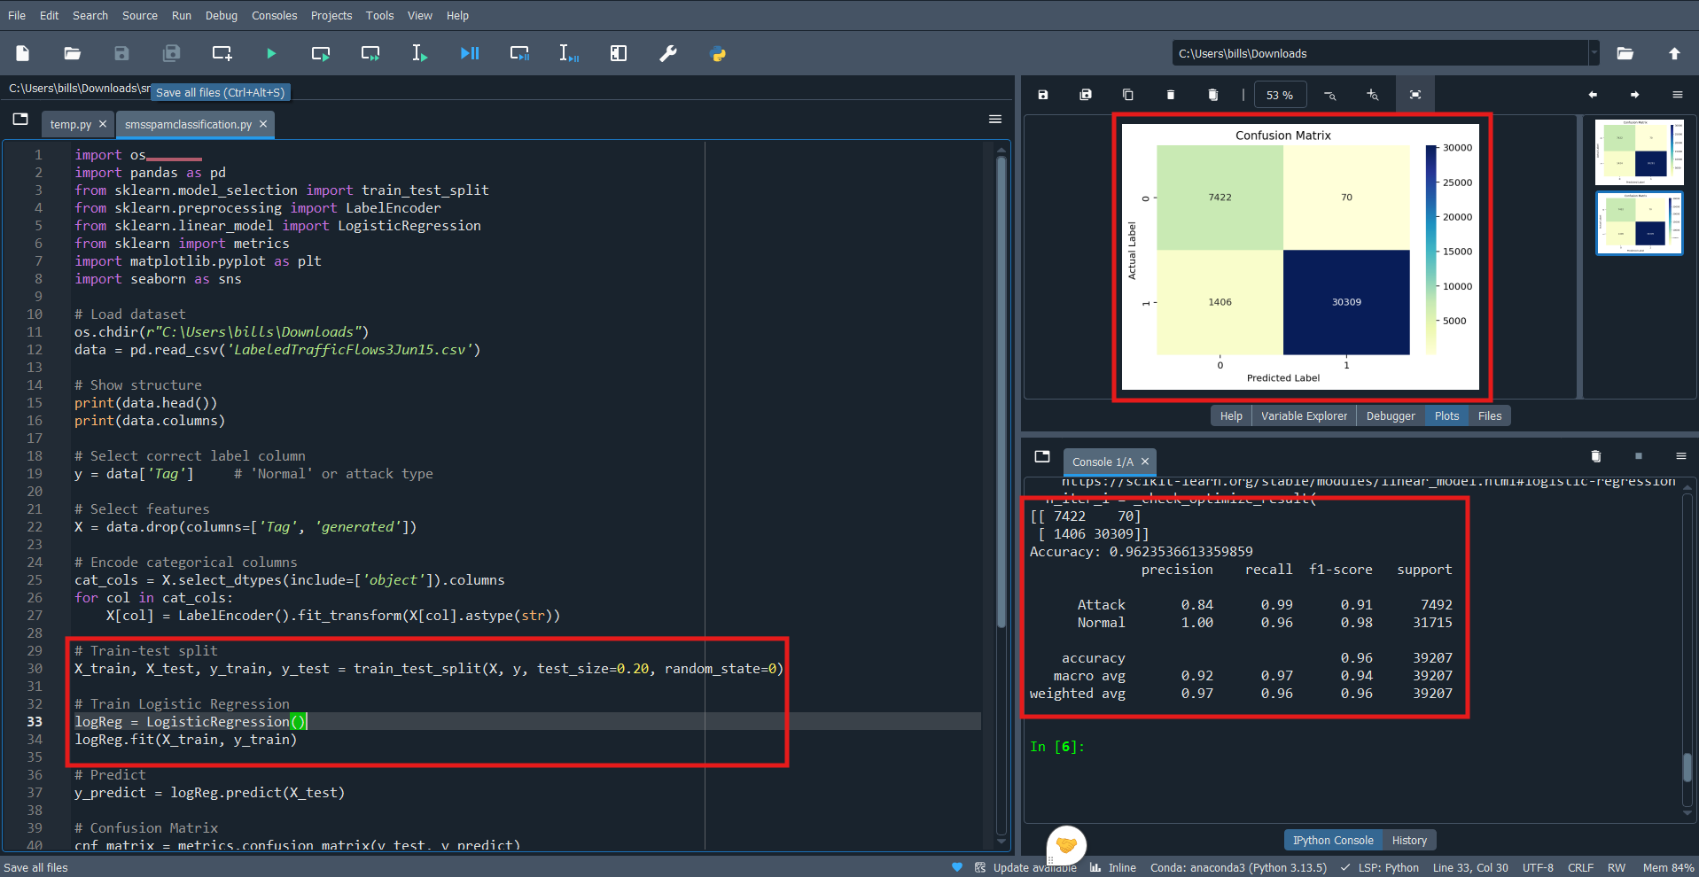

SVM Model:
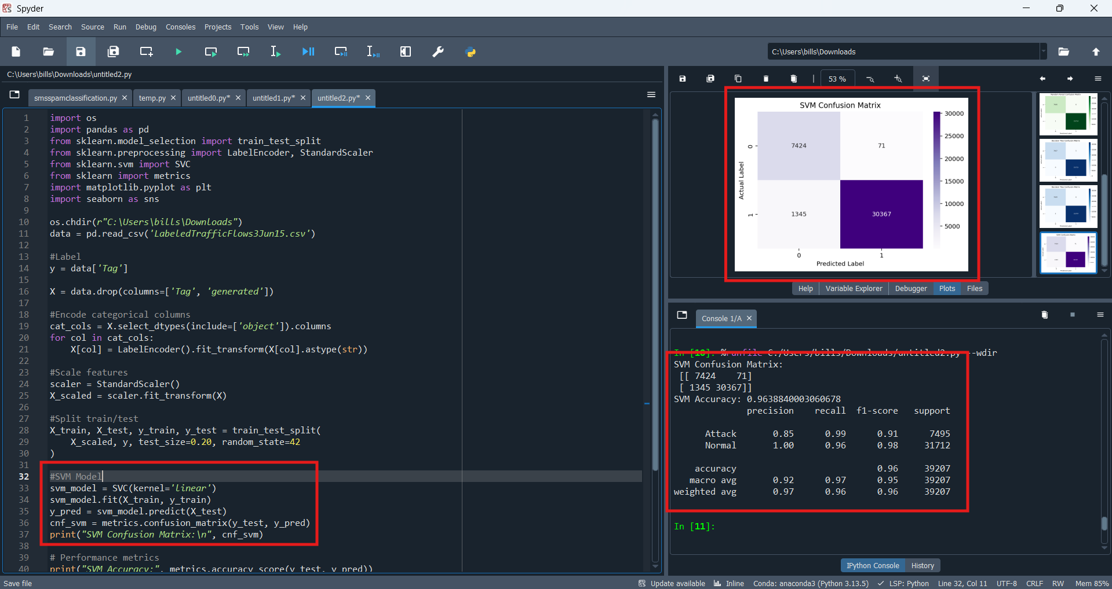
Random Forrest Model:
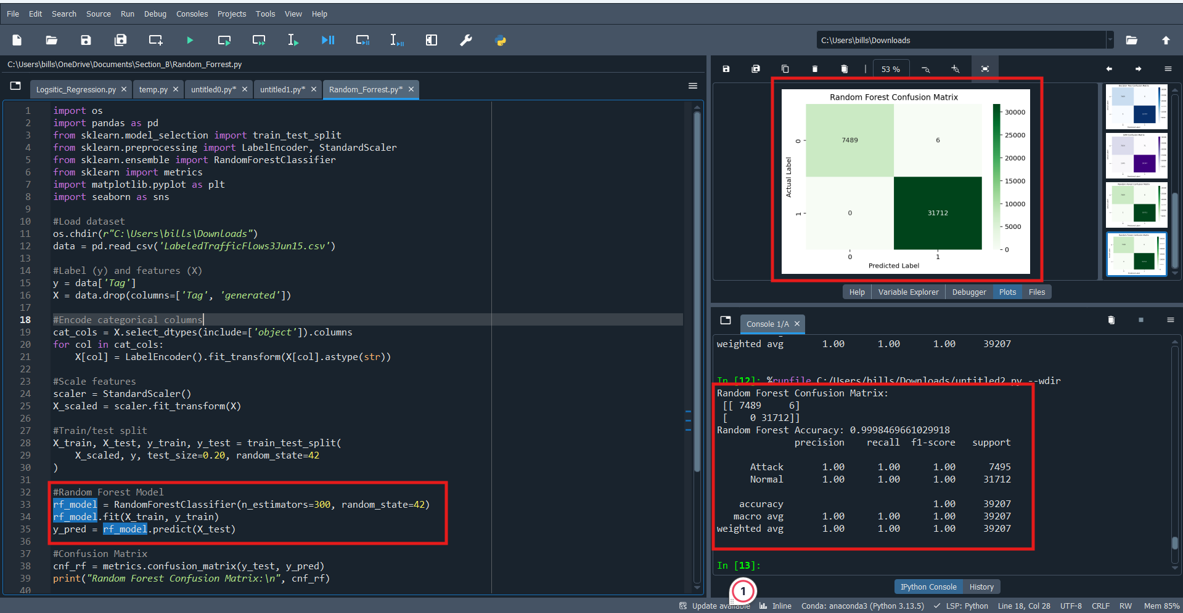

Decision Tree Model:
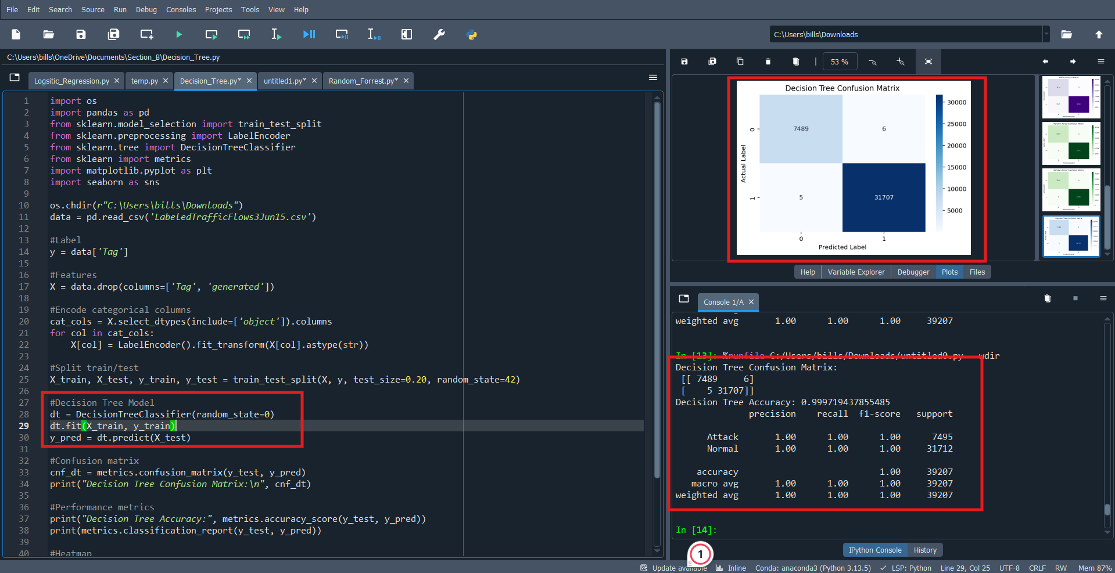

2. Provide the performance of each ML algorithm in terms of the confusion matrix, accuracy, precision, recall and the F1 score. Present the results in table form.
The table below is based on the results from the attack tag.
Type of Classifier | Accuracy Score | Precision Score | Recall Score | F-1 Score
Logistic Regression | 96.2% | 84.0% | 99.0% | 91.0%
Support Vector Machine (SVM) | 96.4% | 85.0% | 99.0% | 91.0%
Random Forest | 99.8% | 100% | 100% | 100%
Decision Tree | 99.7% | 100% | 100% | 100%

3. Discuss the performance results of these experiments and identify the algorithm(s) with the best performance.
The Logistic Regression model performed the worst among all the algorithms with an accuracy score of 96.2%, precision score of 84.0%, recall score of 99.0%, F-1 score of 91.0%, and configuration matrix of [[7422 70] [ 1406 30309]]. The lower accuracy and precision scores show that the model struggled, in comparison to the other models, to correctly identify attack traffic without generating false alarms. The model had a total of 70 false positives, and 1,406 false negatives, which would be very concerning in a real-world security setting. Although the recall score was high, boosting the overall F-1 score, it was not enough to compensate for the model’s difficulty in accurately predicting and detecting attack traffic.
The Support Vector Machine (SVM) model performed slightly better than the Logistic Regression model with an accuracy score of 96.4%, precision score of 85.0%, recall score of 99.0%, F-1 score of 91.0%, and a configuration matrix of [[7424 71] [ 1345 30367]]. Similarly to the last model, the lower accuracy and precision scores showed that the SVM model also struggled to consistently distinguish attack traffic without misclassifying some of the data. This model generated 71 false positives and 1,345 false negatives, which is still too many misclassifications to be used in a real-world security setting. Even with its strong recall score helping maintain a solid F-1 score, the SVM’s overall performance suggests that it is not the best choice for accurately identifying attack traffic from this dataset.
Both the Random Forest and Decision Tree models performed the best with very similar scores, with the only exception being the accuracy scores of 99.8% for the Random Forest model and 99.7% for the Decision Tree model. The other scores were 100% for precision, 100% for recall, 100% for F1-score, and a configuration matrix of [[7489 6] [ 0 31712]] for Random Forest and [[7489 6] [ 5 31707]] for Decision Tree. These models were very successful in accurately distinguishing between normal and attack traffic, with very few misclassifications. The Random Forest model had only 6 false positives, and 0 false negatives making it near perfect in detecting every attack instance in the dataset. The Decision Tree model had a very strong performance as well with 6 false positives and only 5 false negatives. These results show that the tree-based models are much more suited for this data when compared to linear models used earlier.

